EXPERIMENT 1

Title: Construct and Verify the Performance of Bi-Level and Multi-Level Confusion Matrix using Python

⬛ AIM
To construct bi-level (binary) and multi-level (multi-class) confusion matrices using Python and to verify their performance by calculating accuracy.

⬛ ALGORITHM

Algorithm for Constructing a Confusion Matrix (Manual Method)
- Start
- Define the actual class labels (y_true).
- Define the predicted class labels (y_pred).
- Create a list containing all unique labels (e.g., [0,1] for bi-level and [0,1,2] for multi- level).
- Initialize a matrix of size N × N, where N is the number of labels.
- For each pair of actual and predicted values:
  - Find the row index corresponding to actual label.
  - Find the column index corresponding to predicted label.
  - Increment the matrix cell at that index.
- Display the confusion matrix.
- Count the number of correctly predicted values.

Calculate Accuracy = (Correct Predictions / Total Samples).
- Display the accuracy value.

Stop

⬛ INPUT

Bi-Level Input

- Actual (y_true): [0, 1, 1, 0, 1, 0]
- Predicted (y_pred): [0, 1, 0, 0, 1, 1]
- Labels: [0, 1]

Multi-Level Input

15. Actual (y_true): [0, 1, | 2, | 1, | 0, | 2]
16. Predicted (y_pred): [0, | 2, | 2, | 1, | 0, | 1]
17. Labels: [0, 1, 2]
⬛ OUTPUT
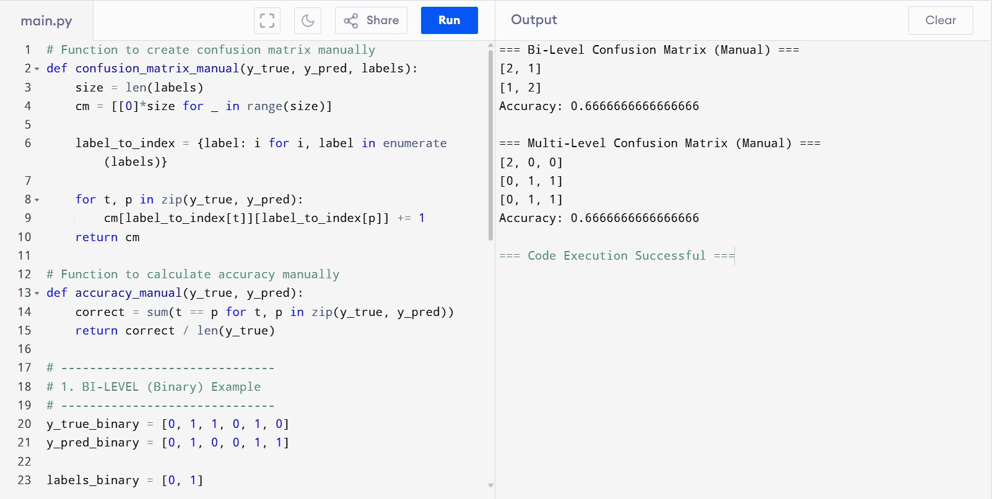

⬛ RESULT
The bi-level and multi-level confusion matrices were successfully constructed using Python.
The performance of both models was verified by manually calculating the accuracy.

